Joint Providership Accreditation Statements

In support of improving patient care, this activity has been planned and implemented by CME Outfitters, LLC. and [educational partner]. CME Outfitters, LLC. is jointly accredited by the Accreditation Council for Continuing Medical Education (ACCME), the Accreditation Council for Pharmacy Education (ACPE), and the American Nurses Credentialing Center (ANCC), to provide continuing education for the healthcare team.

Note: The overall JAC statement appears for all activities. Following the JAC statement, individual statements for credit being offered should be listed as outlined below. ONLY APA requires the use of a logo.

Medicine (ACCME)

Live
CME Outfitters, LLC, designates this live activity for a maximum of xx AMA PRA Category 1 Credit(s)TM. Physicians should claim only the credit commensurate with the extent of their participation in the activity.
Enduring
CME Outfitters, LLC, designates this enduring activity for a maximum of xx AMA PRA Category 1 Credit(s)TM. Physicians should claim only the credit commensurate with the extent of their participation in the activity.

Nursing (ANCC)

This activity is designated for xx contact hours.

Note to Nurse Practitioners: Nurse practitioners can apply for AMA PRA Category 1 CreditTM through the American Academy of Nurse Practitioners (AANP). AANP will accept AMA PRA Category 1 CreditTM from Jointly Accredited Organizations. Nurse practitioners can also apply for credit through their state boards.

Pharmacy (ACPE)

Pharmacists (ACPE): This (application-based or knowledge-based) activity is approved for xx contact hours (0.xx CEUs) of continuing pharmacy credit (Insert JA-UAN).

Physician Assistants (AAPA)
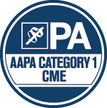

Live
<<Insert AAPA Logo to the left>>

CME Outfitters has been authorized by the American Academy of PAs (AAPA) to award AAPA Category 1 CME credit for activities planned in accordance with AAPA CME Criteria. This activity is designated for XX AAPA Category 1 CME credits. PAs should only claim credit commensurate with the extent of their participation.

Enduring
CME Outfitters has been authorized by the American Academy of PAs (AAPA) to award AAPA Category 1 CME credit for activities planned in accordance with AAPA CME Criteria. This activity is designated for xx AAPA Category xx CME credits. Approval is valid until expiration date. PAs should only claim credit commensurate with the extent of their participation.

Optometry (COPE)
Logo optional

This course is COPE approved for XX hours of CE credit. Course ID is XXXX.

Social work (ACE)

As a Jointly Accredited Organization, CME Outfitters, LLC is approved to offer social work continuing education by the Association of Social Work Boards (ASWB) Approved Continuing Education (ACE) program. Organizations, not individual courses, are approved under this program. State and provincial regulatory boards have the final authority to determine whether an individual course may be accepted for continuing education credit. CME Outfitters, LLC maintains responsibility for this course. Social workers completing this course receive XX (type) continuing education credits.

Dental (ADA CERP)

Logo optional

CME Outfitters, LLC is an ADA CERP Recognized Provider. ADA CERP is a service of the American Dental Association to assist dental professionals in identifying quality providers of continuing dental education. ADA CERP does not approve or endorse individual courses or instructors, nor does it imply acceptance of credit hours by boards of dentistry. Concerns or complaints about a CE provider may be directed to the provider or to the Commission for Continuing Education Provider Recognition at ADA.org/CERP.
CME Outfitters, LLC designates this activity for XX continuing education credits.
Concerns or complaints about a CE provider may be directed to the provider, or to the Commission for Continuing Education Provider Recognition at ADA.org/CERP.

Psychologists (APA)

Continuing Education (CE) credits for psychologists are provided through the co-sponsorship of the American Psychological Association (APA) Office of Continuing Education in Psychology (CEP). The APA CEP Office maintains responsibly for the content of the programs.

Registered Dieticians (RD/DTR)

Completion of this RD/DTR profession-specific or IPCE activity awards CPEUs (One IPCE credit = One CPEU).

If the activity is dietetics-related but not targeted to RDs or DTRs, CPEUs may be claimed with are commensurate with participation in contact hours (One 60 minute hour = 1 CPEU).

Athletic Trainers (BOC)

Statement pending

IPCE
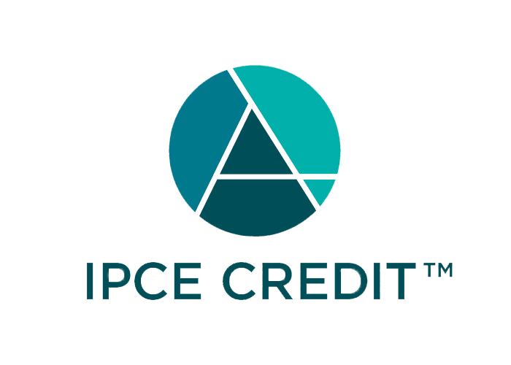
Statement pending

California CNE Credit (Nurses)
Provider approved by the California Board of Registered Nursing, Provider Number CEP 15510, for X.X contact hours.

